**CityDAO Market Research V1**

Original Author: A. Newton

Twitter: [@Crypto_Utopian](https://twitter.com/Crypto_Utopian)

Discord: Crypto_Utopian

GitHub: [Crypto-Utopian](https://github.com/Crypto-Utopian)

Date Created: 7/2/2021

# INDEX

# CITYDAO PROJECT OVERVIEW

# SIMILAR PROJECTS - ANALYSIS

## [RedSwan](https://redswan.io/)

### Project Summary

### Project Details

### Target Market

### Legality

### Technical Analysis

### Profit Model

### Partnership(s)

#### Partnership Analysis

## [CommonLands](https://www.commonland.com/)

### Project Summary

### Project Details

### Target Market

### Legality

### Technical Analysis

### Profit Model

### Partnership(s)

#### Partnership Analysis

## [Ubitquity](https://www.ubitquity.io/)

### Project Summary

### Project Details

### Target Market

### Legality

### Technical Analysis

### Profit Model

### Partnership(s)

#### Partnership Analysis

# DAO RELATED OBSTACLES

## Smart Contracts Obstacles

### Risk of Smart Contract vulnerabilities

### Risk of Internal Manipulation (i.e. disgruntled developer)

### Risk of Incorrect/Bad Data

## Other Obstacles

### ??

### ??

## DAO Risk/Obstacle Mitigation

# LEGAL RELATED OBSTACLES

# RELATED RESEARCH ARTICLES

## Wyoming – Crypto Related Laws/Regulations

## Wyoming – LLC Property Ownership Laws/Regulations

## Federal – Land ownership Laws

## Real estate Ownership on Blockchain

## Fractional Land Ownership

# APPENDIX

## DAO Terms

## Legal Terms

## Blockchain Terms

# REFERENCES & CITATIONS

**1. CityDAO Project Overview**

The initial concept for CityDAO was conceptualized and spearheaded by [Scott Fitsmones](https://twitter.com/scottfits) via a [twitter post](https://twitter.com/scottfits/status/1410724134468739076) following the State of Wyoming passing and enacting [Bill SF0038](https://www.wyoleg.gov/Legislation/2021/SF0038) on July 1st 2021. In summary, Bill SF0038 States the following[[1]](https://www.wyoleg.gov/2021/Summaries/SF0038.pdf):

* + - A decentralized autonomous organization (DAO) is a limited liability company with special provisions allowing the company to be algorithmically run or managed (in whole or in part) through smart contracts executed by computers.
    - This bill creates a supplement to the Wyoming Limited Liability Company Act to provide law controlling the creation and management of a DAO. The provisions of the LLC Act apply to a DAO except as specifically modified by the supplement.
    - This bill establishes baseline requirements for member managed or algorithmically managed DAO's and provides definitions and regulations for DAO formation, articles of organization, operating agreements, smart contracts, management, standards of conduct, membership interests, voting rights, the withdrawal of members and dissolution.

The primary sponsor of this Bill was the Wyoming State ‘[SELECT COMMITTEE ON BLOCKCHAIN, FINANCIAL TECHNOLOGY AND DIGITAL INNOVATION TECHNOLOGY](https://www.wyoleg.gov/Legislation/2020/HB0027)’. This Bill only applies to DAOs registered in the state of Wyoming, as no other state or the federal government has acknowledged DAOs as LLCs[[2]](https://medium.com/predict/a-us-state-government-legalized-dao-for-the-first-time-53723583e51f).

**2. SIMILAR PROJECTS – ANALYSIS**

**2.1** [**REDSWAN**](https://redswan.io/)

**2.1.1 Project Summary**

Red Swan is a [proptech](https://www.techslang.com/definition/what-is-proptech/) company that utilizes the [polymesh blockchain](https://uploads-ssl.webflow.com/5d2ccf16358ee969a317e33d/60dcd72a1451b804115e2084_Polymesh%20Whitepaper_v1.1.pdf?utm_referrer=https%3A%2F%2Fpolymath.network%2F) to create asset backed tokenized commercial real estate using . On their main web page they claim to:

*“[allow investors to] Invest in leading off-market institutional-grade commercial real estate with leading sponsors. Diversify with a digital CRE portfolio that is fully tradable, has early liquidity opportunities & gives you fractional ownership.”*

Their primary focus seems to be targeting investors who want to invest in fractional ownership of commercial grade real estate.

**2.1.2 Project Details**

Red Swan is currently set to tokenize 16 different properties that span the United States and Canada, ranging from cities including Brooklyn, Houston, Oakland, Ontario, and others.

Ed Nwokedi, Red Swan’s CEO, says tokenization provides a method of increasing investor access to real estate assets. What was previously confined to institutional investors and high net worth individuals can now be accessed by accredited investors.

**2.1.3 Target Market**

The token sale will target investors seeking to deploy between $500,000 and $10 million — who lack the capital to purchase top level ‘Class A’ commercial real estate in traditional markets, and have been forced to consider lower-grade, riskier investment opportunities.

**2.1.4 Legality**

RedSwan CRE issues the CRE tokens through a Limited Liability Company called the “Red Swan Real Estate Fund LLC” (the “Fund”), which is also a Registered Investment Advisor (“RIA”).  When you invest in a particular property, you are effectively investing in a “series” within the Fund.  RedSwan CRE, as the fund manager, selects what series (i.e., property investment opportunity) are offered within the Fund.

The Fund also acts as its own registrar.  What this means in practice is that all the tokens that are issued are custodied on behalf of the investor in a single, secure vault at Coinbase, our partner custodian.  RedSwan CRE assigns owners to the tokens once they are allocated and paid for by investors.  On a go forward basis, RedSwan CRE manages the list of registered investors and ensures that important property information and financial updates are provided and that dividend payments are properly forwarded to token investors.

Generally, when a company/project wishes to issue securities to investors, the issuer must register them with the US Securities and Exchange Commission (SEC).  However, by limiting our token offerings to Regulation D Accredited US investors and Regulation S international investors, we can have our offerings exempt from full SEC registration.  This helps reduce the time and cost of raising capital for real estate sponsors and helps you get quicker access to investment opportunities.  Under Reg D and S, RedSwan CRE does have the ability to advertise offerings publicly but can only accept US Accredited Investors and any investor outside of the US.

**2.1.5 Technical Analysis**

A Token created by RedSwan is simply a digital representation of an asset.  A token by itself does not have any intrinsic value but is linked to an underlying asset that has value. The tokens invested through RedSwan CRE represent equity ownership in actual properties and thus derive value from them.

In the figure below (Figure 2.1.5a), you can see the process flow

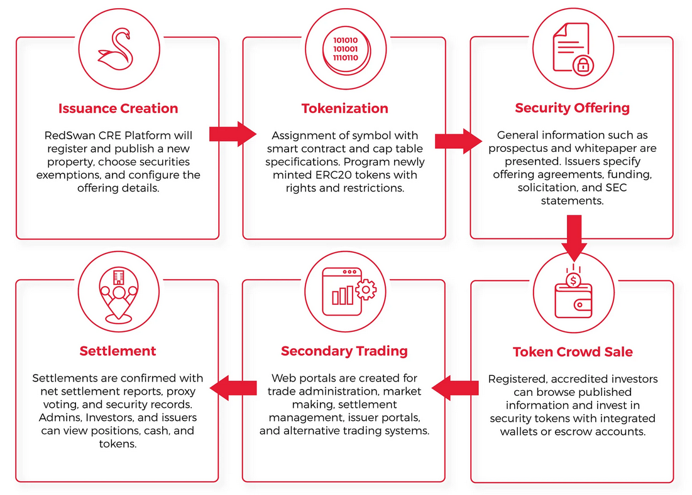

Figure 2.1.5a – RedSwan Real Estate Tokenization process flow.

**2.1.6 Profit Model**

**7. REFERENCES & CITATIONS**

1) Wyoming Legislative Service Office. Decentralized autonomous organizations. 1 July 2021. Document. 2 7 2021. <<https://www.wyoleg.gov/2021/Summaries/SF0038.pdf>>.

2) E2Analyst. “A US State Government Legalized DAO for the First Time.”. 30 May 2021. Medium, Predict. Blog. 2 July 2021. < <https://medium.com/predict/a-us-state-government-legalized-dao-for-the-first-time-53723583e51f>>.